Lab 7

Kevin Wang

Chelsey Yin

Our circle detector uses Hough transform to find fixed and arbitrary radius circle in the different background. The parametric representation of a circle we used is ${(x-x_{c})}^{2}+{(y-y_{c})}^{2}=r^{2}$. For each picture, we used the same logic and most of the parameters. However, to achieve a higher accuracy, we tune the parameters manually for them.

**Fixed radius**

To find fixed radius circles, we use morphology method, in particular open, to clear noise around the circle, and form a nice circle before getting into the Hough transform process. This may or may not affect detector’s decision.

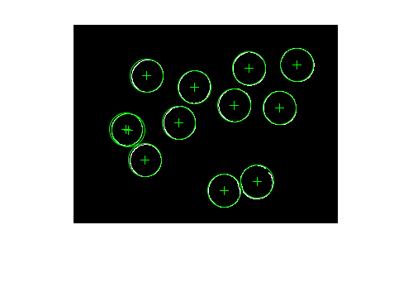

For fixed1.jpg, the coins do not any overlaps and the background is clear. Therefore, the accuracy is reasonable high. However, there are two circles found in the same coin. Although our detector tries to remove duplicated circles by only allowing the circles to draw a certain distance from existing origins. However, the two origins that are not that close. Therefore, it is still in the picture.

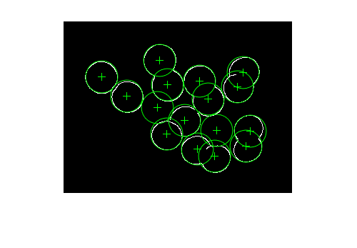

For fixed2.jpg, some coins have overlap and the background is clear. We found one more circle because this circle touches four other circles. Therefore, the points of these four circles vote a new circle which does not exist in the picture.

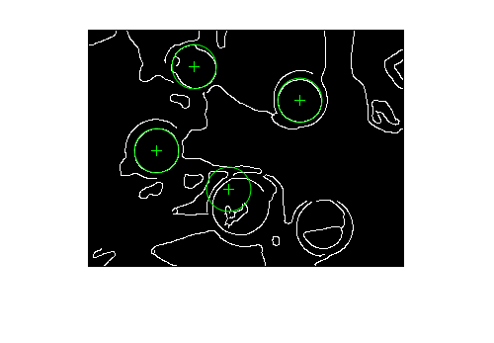

For fixed3.jpg, coins are separated but the background is extremely misleading. Therefore, the edges we get will include many unrelated background information. We mistakenly found one circle and missed one circle. Some curve things in the background not clear or largely affect the edges of the circle. Therefore, it fails to vote for a complete circle.

Then we tried to detect circles with an arbitrary radius. This one is more difficult than the fixed one, and the correction rate is low for some images. We treat r as another parameter and loop through a reasonable size of the radius and record values in a 3D parameter space.

**Arbirary radius**

We used two methods. One of them is just getting data from the raw parameter space. The other one, we tried to put three nearby neighbors together. The result should be better with the combined space, but our result is not the case. We also tried to remove the close circles, but some real circles are close to each other. The range we can set is limited. Since we are using the changing radius, we often get some unexpected circles just because they can be formed with some different edge points. Things might be improved: We may also include the information of the direction of the gradients so that we only need to search points in that direction. This will speed up our program and gives us higher accuracy because it will throw out some strange formed circles. We may set a more reasonable lower bound for the radius. Therefore, we would have many unexpected small circles.

For the first picture, it has no overlaps and the background is clean. Using the raw data, we found most of the circles, but also found some small circles inside them, which are the styles on the coins. There is also one circle that we did not detect, but we have no idea why it does not.

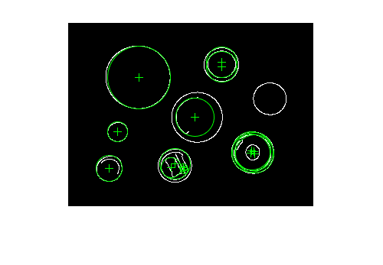

Without compacted data

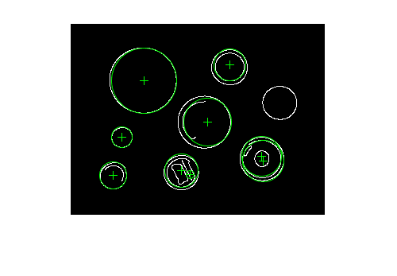

With compacted data

Using the compacted data, the situation is almost the same for this picture.

For the second picture, it has some overlaps and the background is clean. Using the raw data, we found some of the circles in the image, but most of the circles we found are not actually circles, but the combinations of some circles together. We increase the range of our radius used in the picture because it has larger circles. Many small circles we found are not real circles. One reason may be we set the smallest radius too small. The other may be the edges are quite close to each other and their intervals will be able to form a circle that connects to some of the points.

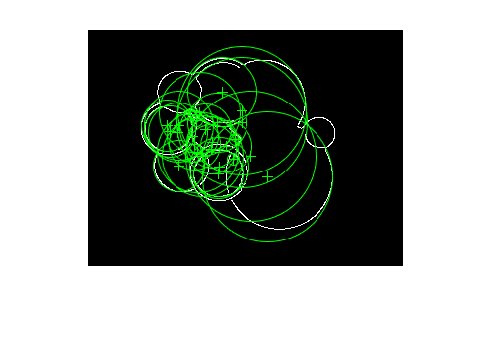

Without compacted data

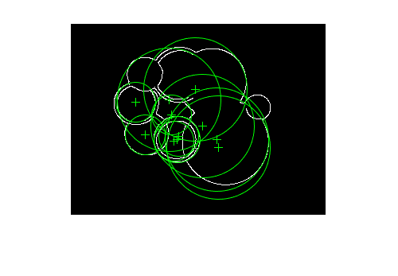

With compacted data

Using the compacted data, we found more unrelated circles. Because the data become larger when we put them together. However, we have to keep the threshold to include those large circles.

For the third image, it has no overlaps, but the background is quite noisy. Using the raw data, we just find few circles on it. Some of the circles are close to each other, which are actually one real circle. We do not know why some real circular shapes did not be detected to be circles.

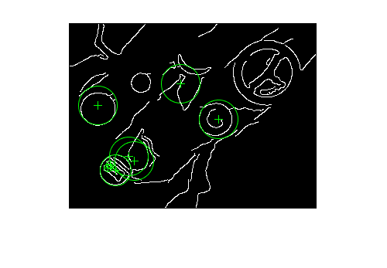

Without compacted data

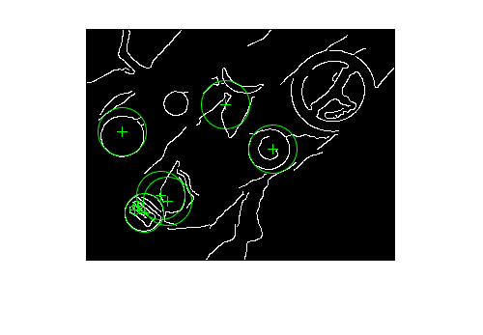

With compacted data

Using the compact one, we found more circles, but also lead to more non-circles been found.